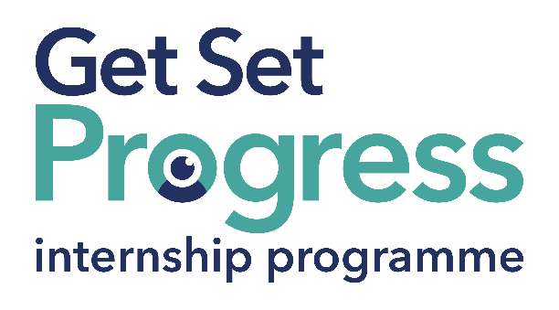 

# Fundraising Officer

## Join us at 4Sight Vision Support

Thomas Pocklington Trust (TPT) and RNIB are collaborating with organisations from both the sight loss and wider charity sector as well as corporate organisations to create new opportunities for blind and partially sighted people to find employment through the Get Set Progress (GSP) Internship programme. 4Sight Vision Support is delighted to be offering an internship as part of the Get Set Progress scheme.

## About 4Sight Vision Support

4Sight Vision Support (4SVS) was established in 1921 to support blind and partially sighted people living in West Sussex. We currently support around 3,500 clients, however, there are an estimated 36,200 people living with sight loss in our County.

Our mission is to make a positive difference to blind and partially sighted people in West Sussex at every stage of their lives and sight loss journey. We do this by providing specialist support and advice, enabling people to live Life Without Limits. We are caring, forward-thinking and trusted, and we want everyone involved with our organisation to see that and feel like part of our family.

GSP’s aim is to Support, Enable and Evolve people across West Sussex who are blind or partially sighted to keep their independence, stay in/find employment or education, remain connected to friends and family and continue to be active members of the community. Our priorities are to increase the number of people we support who are blind or partially sighted, ensure our services are relevant and use led through continuous engagement. promote the importance of good eye health and sight loss prevention, raise our profile across West Sussex and ensure we are fit for purpose and sustainable.

## What are the benefits of a Get Set Progress internship for me?

As part of your 9-month internship, you will be part of a large cohort of fellow interns and gain the following:

* Obtain valuable work experience within the charity sector
* Technology support (Including Microsoft Office) and upskilling opportunities
* Online and in-person Training and development opportunities
* Opportunity to present and network with Senior leaders within the Sight Loss Sector
* Opportunities to build relationships with fellow interns
* A personal mentor offering support, advice and guidance throughout your internship
* Help deliver positive changes for people with sight loss

Blue and Teal coloured Works for Me logo featuring a graphic of an eye within the O in 'works'. with employment programme written in smaller letters underneath in dark blue. 


As part of the GSP Internship programme, you will also be enrolled on the TPT **Works For Me** Employment Programme, where you will gain bespoke employment support, guidance and advice from the TPT Employment Team, some of the skills that you will receive support and guidance around include:

* CV writing
* Job searching
* Cover letter and speculative letter writing
* Application form writing
* Interview techniques

## **Job description**

Role: Fundraising Officer

Department: Fundraising

Reporting to: Fundraising Manager

Location: Hybrid, at least 3 days in the office / Shoreham by Sea

Salary: Based on the [Real Living Wage](https://livingwage.org.uk/)

Contract type: Fixed Term, 9 months Full time – 35 hours a week

## Job Specification Information

To generate income for 4Sight Vision Support through different types of donations from individuals, and grants from trusts and foundations. To write compelling appeals, develop upon the existing stewardship programme, developing our legacy fundraising, researching individual and funder opportunities, maintaining a pipeline of funding applications to trusts and foundations, and develop more engaged relationships with all supporters for the long-term sustainability of the Charity. Be a contributing member of the wider organisation.

Key areas of responsibility

* Develop existing individual income streams to achieve their potential – appeals, in-memory, regular giving, legacy.
* Develop a major donor programme, including events and communications.
* Thank and build long-term relationships with all donors (individuals and trusts).
* Research and maintain up to date information about high value donors, analyse and assess appropriateness of approaches.
* Conduct thorough research to keep abreast of changes in individual giving trends and identify new opportunities.
* Maintain a pipeline of funding applications, including writing compelling cases for support, completing applications, reporting back to funders to ensure continued support.
* Use a variety of resources to research and maintain up to date information about warm funders, analyse and assess appropriateness of applying to cold and lapsed funders.
* Liaise with key colleagues to ensure fundraising makes the most of existing opportunities and is focused on areas of need.
* Contribute to the further development of optimal CRM (Donorfy) usage for planning and reporting work, with the Fundraising Manager.

**Personal specification - Essential criteria:**This post has a Genuine Occupational Requirement that the successful applicant be a person who is blind or partially sighted, in line with The Equality Act 2010

* Willingness to travel to the TPT Hub in London for intern development events throughout the course of the internship programme (costs covered by TPT).
* Having **not** previously undertaken the Get Set Progress internship programme.

(Please insert additional information)

## What to do next

To apply for this position please go to our website, via the link below, download and complete our application and equal opportunities monitoring forms. Please return these to us at [recruitment@4sight.org.uk](mailto:recruitment@4sight.org.uk).

[Vacancies At 4Sight Vision Support - 4Sight Vision Support](https://www.4sight.org.uk/vacancies-at-4sight/)

## **Closing date**

Monday 11 August at 5 pm.

DOCUMENT ENDS