Charity Number:1075447
Read more on Pg 3
4Sight Vision Support Newsletter

Winter 2019

“Your visit today was monumental and we are so pleased that you have provided help and information to help our Dad.“

Company Number:3740647

In this Issue:

Pg 3: The Sight Loss MOT
Pg 4-5: CEO’s Message
Pg 6: Volunteering
Pg 7: Fundraising News & Events
Pg 8: Arun Updates
Pg 9: Mid & North Sussex
Pg 10: Midhurst & Chichester
Pg 11: Shoreham & Adur
Pg 12: NEW Activity Hub
Pg 13: Second-hand Items
Pg 14: News and Views
Pg 15: How to donate

If you have any inserts for the next newsletter:
Call: 01243 838001 or Email: marketing@4sight.org.uk

If you have any comments on how we can continue to update
this or any of our other services, please let us know:

Call: 01243 828555 or Email: feedback@4sight.org.uk

Printed by University of Chichester

Tel: 01243 812100

printshop@chi.ac.uk

The Sight Loss MOT

Building on national strategies and research, our colleagues at Devon in Sight has developed an innovative ‘Sight Loss MOT’ to help identify the services, support and training that helps people living with sight loss maintain their independence and well-being. 4Sight Vision Support is now able to offer the Sight Loss MOT to our members, a holistic and bespoke needs assessment that will enable us to better understand how we can best help you.

The MOT focuses on the following areas: Understanding your eye condition, making the best use of your sight, your health and well-being, managing at home, getting out and about, your finances and planning for the future, learning, work and having your say. The Sight Loss MOT will identify what/if

additional support might be helpful – particularly if you have been newly diagnosed with sight loss, or if your condition and support needs have changed.

We will also be able to check that you are receiving allowances and entitlements through registering as being sight impaired, and have the opportunity to chat to someone about the emotional impact of living with sight loss.

“Your visit today was monumental and we are so
pleased that you have provided
help and information to
help our Dad. | “

If you would like to find out more about this service, please contact Karen Mclachlan on 01243 838 007 or email karen.mclachlan@ 4sight.org.uk

3

CEO’s Message

Dear Members,

As I write, I am reflecting on just how quickly the year is drawing to a close! With the imminent arrival of 2020 we will embrace the challenges and successes of the forthcoming year.

As we wait to welcome the new year, I would like to share the following with you.

On the 26th October we held our 2019 AGM in our

newly refurbished Activity Hub in Bognor Regis. Over 40 people attended the AGM and afterwards enjoyed a hot meal of sweet potato and butter-nut squash curry which was provided by the charity UK Harvest. We were very pleased to have so many members and colleagues there with us to share in the day as we looked back on a positive and successful 2018/19 year.

At the start of this year, we undertook the task of gathering the thoughts and feedback of our members. I’m pleased to say that over 1500 of you kindly took the time to respond and I’d like to share some of the results with you now;

Positive Difference Overall, 93% stated that we have made a positive difference to you.

34% stated that purchasing equipment from our Centres has made the most difference to you, followed by 29% who said that receiving the Newsletter as a means of regular communication also made a difference.

4

Confidence & Independence 72% stated that as a result of using our services they felt more confident, had more self-esteem and have gained more independence.

Services & transport

To further improve the services available to you, 40% said that transport to/from hospital/ doctor’s appointments, shopping and outings would be welcome.

Support

69% said they felt supported by us and 63% felt better informed.

These are just a few of the results from the survey, if you would like a copy of the full results, then please do call us on 01243 828555 and we will send a copy to you.

Your valuable feedback reassures us of the things that we are doing well, and alerts us to the things that we need to improve upon or develop anew in order to successfully meet

the ever-changing needs of people living with sight loss in West Sussex.

On behalf of the whole team here at 4Sight Vision Support, we would like to thank you for taking part in our survey and for sharing your views with us.

I would also like to take this opportunity to wish you all a Happy Christmas and a prosperous and healthy 2020.

Nik Demetriades, CEO

Christmas & New Year Closing times for Support Centres:

Bognor Regis closes: 1pm on Tuesday 24th December and re-opens at 10am on Thursday 2nd January 2020.

Midhurst closes: closes 1pm on Monday 23rd December and re-opens at 10am on Thursday 2nd January 2020.

Shoreham closes: 2pm on Thursday 19th December and re-opens at 10am on Thursday 2nd January 2020.

5

Volunteering

Would you like to help us make a positive difference?

We have a wide variety of volunteer roles to suit different interests and skills and would love to help find the perfect role for you. For more info or to request a volunteer pack, please call Karen: 01243 828555.

We urgently need: Volunteer Club Leaders, Volunteer Minibus Drivers for our clubs in Littlehampton and Rustington, Volunteers for our Kitchen Klub at Bognor and Volunteer Sighted Guides for our new walking group in the Arun area.

NEW Role: Newsletters

With our membership numbers increasing, we now produce a larger number of A4 size newsletters which need putting into envelopes. We would welcome some help with this volunteering role that takes place four times a year at our Bognor Regis Support Centre. ₆

Mid Sussex Applauds Awards Sunday 13th October - We had an enjoyable afternoon at the Award Ceremony where Dorothy Lazenby won the Lifetime Achievement Award for an individual who has made a substantial commitment to the community in their lifetime.

Dorothy also went on to win the Peer Nominated Award where all award nominees were given the chance to vote for their favourite.

Congratulations to Dorothy for winning both awards and a very big thank you for 38 years of volunteering at 4Sight Vision Support as Club Leader at the Clayton and Hassocks Clubs as well as the Haywards Heath Readers group.

Fundraising News & Events

Here are some ways you can get involved and help us raise vital funds to support what we do.

Tesco Bags of Help Centenary Grant

Keep voting with Tesco blue tokens across Sussex for the 'Centenary Sight Angels' - we could be awarded up to £25,000 to make a hugely positive difference for people living with sight loss across East and West Sussex as we work with ESAB and Tesco.

Voting ends 31st December. Co-op Cause

This past year your support raised £2,312.21 for Low Vision Assessments, Thank You.

We are excited to say that the Co-op will be supporting us again this year for the 3rd year running. Co-op members can select us as their chosen cause and help raise money as they shop, from now unitl October 2020.

Burns’ Night Celebrations Thursday 23rd January 2020
Our popular event is back and at a larger venue, so we can welcome even more guests than before.

6:30pm (Bar open from 6pm, food served at 7pm) Restaurant 64, Chichester College, Westgate Fields, Chichester, PO19 1SB

Tickets are £25pp and include: 4-course meal including a whisky toast. Music by: Celtic Simbel, Scottish piper & singers. On the night there will also be a Bar & Raffle. Parking available in the College Car park, 50p for 24 hours.

200 Club - Win £100

Join the 200 club for just £20 a year and be in with a chance to win £100 each month. To join today, call: 01243 828555. Latest winning numbers: September - 81, October - 16, November - 184,

7

Arun Updates

For more information on the following updates, please call Kirsty on: 01243 828555 or email:enquiries@4sight.org.uk

New Peer Support Group

An opportunity for people who have sight loss due to a brain injury or stroke, to share experiences and support each other. Friends, family and

carers welcome. Refreshments will be served. Every 3rd Thursday of the month

10.30am – 12.30pm. Held in the Bognor Regis Vision Support Centre.

New Games Group

Join us for an afternoon of games for example cards, dominoes, bingo and scrabble, refreshments will be served.

Every 2nd Friday of the month 1.30-3.30pm starting Friday 14th February 2020. Held in the Bognor Regis Vision Support Centre.

Chat, Cake and Coffee Morning Why not come and meet the team and chat with other

members, whilst enjoying cake and coffee or tea! Every last Friday of the month 10am -

11.30am, held in the Bognor Regis Vision Support Centre.

Littlehampton Drop In

Join Arun Outreach Worker, Kirsty Isted, at Littlehampton Library, for information and

support for anyone affected by sight loss. 1st Wednesday each month, 10am - 12noon.

Bognor Macular Support Group Meeting open for anyone

affected by central vision loss. DAY CHANGE - Now every 2nd

Wednesday of the month, 10:30am - 12:30pm.

- The group is also looking for people to assist with

general tasks such as welcoming members, booking guest speakers, and other tasks to help make a positive difference.

8

Mid & North Sussex

For more information on the
following updates, please
call Tara, on: 07545 501216
or email:

tara.beesley@4sight.org.uk

Horsham Area Committee

Would you like to be involved in the Horsham Area committee? This is a great way to meet new people and be involved with fund-raising, events and clubs in your local area. For more information, please call Tara or Naomi on 01243 828555.

The Mid Susssex Tandem Ride A very big thank you to Anne Tomlinson, who put many hours of hard work into organising this hugely successful event again this year. The 2019 ride comprised of 10 tandems, each with a sighted pilot on the front and their visually impaired stoker on the back, cycling a 40 mile circular route through Mid Sussex. It raised £1,785 in 2019, a current grand total of £7,647 over 3 years of this event.

Drop In Sessions

If you need support or have any questions about sight loss, please pop in to your local Drop In and see Tara, our dedicated Outreach Worker for this area.

Burgess Hill:

First & Third Thursday of the month, 9am - 1pm. Burgess Hill Town Council, RH15 9AS.

Crawley:

Second Monday of the month, 10am - 2pm. Crawley Library, RH10 6HG.

East Grinstead:

Third Tuesday of the month, 10am-2pm. East Grinstead Library, RH19 4SR.

Haywards Heath:

First Tuesday of the month, 9am - 1pm. Haywards Heath Town Council, RH16 1BA

Horsham:

First Wednesday of the month, 9am - 1pm. Age UK, Lavinia House, RH12 1GZ

9

Midhurst & Chichester

 | For further information |  |  |  | Chichester Drop In
 | regarding the activities & |  |  |  | Second Friday of each month,
 | events listed below, or to |  |  |  | 9am - 11am at Chichester
 | suggest other activities for the |  |  |  | Library, PO19 1QJ - until March
 | area, please call Dan on: |  |  |  | 2020. Our Outreach Worker,
 | 01730 812 338 or email: |  |  |  | Dan, will be joined by a
 | midhurst@4sight.org.uk |  |  |  | member of the WSCC ROVI
 |  |  |  |  | team to answer any questions
 | Tech Group
 |  |  |  |  | you may have.
 | Second Tuesday of each month,
 |  |  |  |  | Synapptic Support Group
 | 10:30am at the Midhurst
 | Centre. Next scheduled dates |  |  |  | Some of our local members are
 | are 14th January, 11th February |  |  |  | keen to set up a peer support
 | and 10th March. |  |  |  | group for people using
 |  |  |  |  | Synapptic Software on their
 | Coffee Morning
 |  |  |  |  | smart devices. Group members
 | Last Thursday of each month, |  |  |  | will be able to support and
 | 11am at the Midhurst Centre. |  |  |  | advise each other on how to get
 | Next dates are 30th January, |  |  |  | the most out of the software.
 | 28th February and 26th March. |  |  |  | If interested, please do get in
 |  |  |  |  | touch.
 | Games Group
 | Every Wednesday, 1pm at the
 |  |  |  |  | 2019
 | Midhurst Centre. Next date 8th |  |  |  | As another year draws to a
 | January. |  |  |  | close it's nice to reflect on the
 |  |  |  |  | positives of 2019, including a
 | Macular Support Group
 |  |  |  |  | successful fundraising
 | Third Wednesday of each
 |  |  |  |  | concert, flourishing peer and
 | month, 10:30am at the
 |  |  |  |  | social support groups, and the
 | Midhurst Centre. Next dates
 |  |  |  |  | launch of a new monthly drop
 | are 15th January, 19th February
 |  |  |  |  | in service at Chichester Library.
 | and 18th March.
 |  | 10

Shoreham & Adur

 | For more information about any |  |  |  | Health & Wellbeing Event
 | of the following, please call |  |  |  | 27th February 2020, 10am-
 | Kirstie on: 01273 454343 or |  |  |  | 1pm. A chance to meet
 | email: shoreham@4sight.org.uk |  |  |  | organisations, charities and
 |  |  |  |  | businesses that can support
 | The Wellbeing Café
 |  |  |  |  | your health and well-being in
 | The newly refurbished Wellbeing
 |  |  |  |  | the local area. Free event held
 | Cafe at The Hub is proving popular
 |  |  |  |  | at Sight Support Worthing,
 | with the local community. Kirstie |  |  |  | BN11 3JT.
 | will be attending the cafe on
 |  |  |  |  | Charles Bonnet Support Group
 | Monday 10th February 2020.
 | 9am - 12noon, The Hub, 19 |  |  |  | Tuesday 28th January at
 | Church Lane, Upper Beeding, |  |  |  | 1:30pm - 3:30pm, held at the
 | BN44 3HP. |  |  |  | Shoreham Centre. This will be
 |  |  |  |  | an informal gathering, to be
 | Worthing Hospital
 |  |  |  |  | patient led so will be more
 | Jan Hirst and Jenny Goodlad meet
 |  |  |  |  | about your own experiences.
 | every other Thursday, at |  |  |  | Judith Potts from Esme's
 | Worthing Hospital or in the
 |  |  |  |  | Umbrella will also be attending
 | Community Centre in Shoreham
 |  |  |  |  | to give a talk. If you are
 | by Sea. Set up with a table
 |  |  |  |  | interested please call to reserve
 | displaying information leaflets &
 |  |  |  |  | your place.
 | posters - the aim is to make the
 |  |  |  |  | Southwick Coffee & Social
 | general public aware of the
 | services and support available for |  |  |  | Group
 | people living with sight loss. |  |  |  | 1st and 3rd Tuesday of the
“ |  |  |  |  | month, 10am - 12noon. A
 |  | We usually have a very |  |  | growing coffee group that
 |  |  |  |  | meets regularly as well as
 | pleasant morning socialising |  | “
 |  |  |  |  | additional outings.
 | together & with all our visitors.
 |  |  | 11

NEW Activity Hub

We have proudly opened the New Activity Hub in Bognor Regis. Located within the Bognor Regis Vision Support Centre, this new room will enable us to cater for larger groups of members and visitors. We can now make social clubs and activities more accessible and inclusive due to the large multi-purpose room.

Many thanks to everyone who helped fund the project including: The Clothworkers' Foundation, The W G Charitable Trust, The Screwfix Foundation & the WSCC Community Initiative Fund.

During it's first few days the hub successfully hosted our AGM and our first VI Fun Day.

Our VI Fun Day welcomed children and young people living with sight loss, along with their families to enjoy a fun-filled and supportive day. We had over 40 attendees and even a Unicorn!

12

Second-hand Items

We have a selection of second-hand desktop video magnifiers on offer at our Bognor Regis Vision Support Centre available for you to purchase via a donation. (these machines when new normally retail for over £1000)
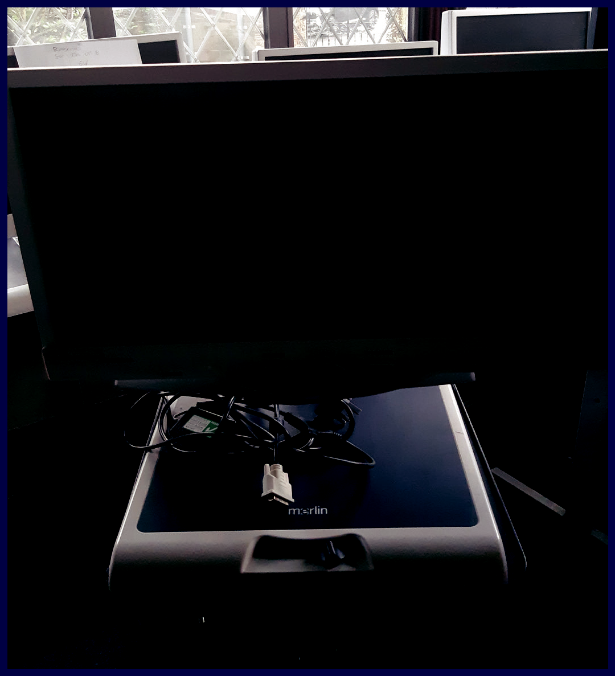

Please note: All items have been tested and are in working order. (Sold as seen and non-refundable.)

We also have two Talking Microwaves available.

These can make cooking in the kitchen more accessible to support your independence.

If you have any questions regarding these items or would like to visit the centre to view them then please contact

Beau Prince: 01243 838002

13

News & Views
Gideons International Bible |  |  | Updating Contact Information
Would you like a copy of the |  |  | To ensure that you still receive
new Testament and Psalms? |  |  | information on our services
We can send you a hardback |  |  | and our newsletter, please
copy in large print, free of |  |  | could you contact us if any of
charge, please call the Bognor |  |  | your personal details change.
Regis Vision Support Centre on |  |  | This includes information such
01243 828 555. |  |  | as a change of address,
 |  |  | telephone number or email
Sussex Coast Talking News |  |  | address. Call: 01243 828555
The talking news features local
 |  |  | Centre Contact Details
news from Bognor Regis in the
west to Lancing in the east and |  |  | and Addresses
is published once a fortnight in |  |  | Bognor Regis Vision Support
two editions – one for
Littlehampton and Arun area, |  |  | Centre: 36 Victoria Drive,
and the other centred on |  |  | Bognor Regis, West Sussex,
Worthing and Shoreham and |  |  | PO21 2TE. Tel 01243 828 555
its surrounding area. As well as |  |  | Shoreham Vision Support
local news there is also a
magazine that covers a wide |  |  | Centre: First Floor, The Shoreham
range of interests including |  |  | Centre, 2 Pond Road,
history, travel, music, hobbies, |  |  | Shoreham-by-Sea, West Sussex,
gardening and much more. |  |  | BN43 5WU. Tel: 01273 454 343
Founded in 1975 as a charity by |  |  | Midhurst Vision Support
members of the Rotary Club of
Littlehampton, it is run entirely |  |  | Centre: Knockhundred Row,
by a team of volunteers. |  |  | Midhurst, West Sussex, GU29
If you would like to become a |  |  | 9DQ. Tel: 01730 812 338
listener, please call them on |  |  | Email: enquiries@4sight.org.uk
01903 776569.
 |  | 14

Make a positive difference at this festive time of year
Type of Donation

Regular Gift via Standing |  |  | Order
I would like to make a |  |  | monthly |  | quarterly |  | yearly
donation of: | £5 | £10 |  | £20 | Other |  | £

Please complete these details:
Bank Name……………………......……Branch………………………………………..
Bank Address ……………………………………………………………………………….
……………………………………………………………………………………………………..
...........................................................................................................
Sort code | - | - | Account Number

Name of Account holder……………..……………………………....................

I authorise the payment on ………………… (date of 1st payment) and
thereafter on the same date each month/quarter/year as stated above, until countermanded by me, to the account of

4Sight Vision Support at CAF Bank Ltd, 25 Kings Hill Avenue, Kings Hill, West Malling, Kent, ME19 4JQ

Account No: 00029420, Sort Code: 40-52-40

Signature ………………………………... Date …………….…………………

One-off Gift
Cheque: I enclose a cheque for £

Please make payable to: 4Sight Vision Support

and send to: 4Sight Vision Support, 36 Victoria Drive, Bognor Regis,
West Sussex, PO21 2TE

Card: Please call 01243 828555 to give securely over the phone. or online at www.4sight.org.uk/donate

15 Appeal Code: Ch19News

Gift Aid it
Boost your donation by 25p of Gift Aid for Every £1 you donate.
This donation is at no extra cost to you, or the charity.

One tick, for 25% bigger impact.

I am a UK taxpayer and I would like 4Sight Vision Support to treat all donations I make in the future or have made in the past 4 years with Gift Aid.

Title: ................................ | First Name: ................................
Surname: ................................................................................
Full Address: ..........................................................................
Postcode: ........................ | Date: ................................

I understand that if I pay less Income Tax and/ or Capital Gains Tax than the amount of Gift Aid claimed on all my donations in that tax year it is my responsibility to pay any difference.

Please notify us if you want to cancel this declaration, or of any changes to your name, address or if you stop paying sufficient tax.

Your Details

We would like to keep you up to date with news on the difference your gift has made, member stories as well as fundraising events and campaigns.

I confirm I would like to receive these fundraising updates

I confirm I am happy to receive information by post (to the above address)

I confirm I am happy to receive information by email

.....................................................................
I confirm I am happy to receive information by phone call

.....................................................................

