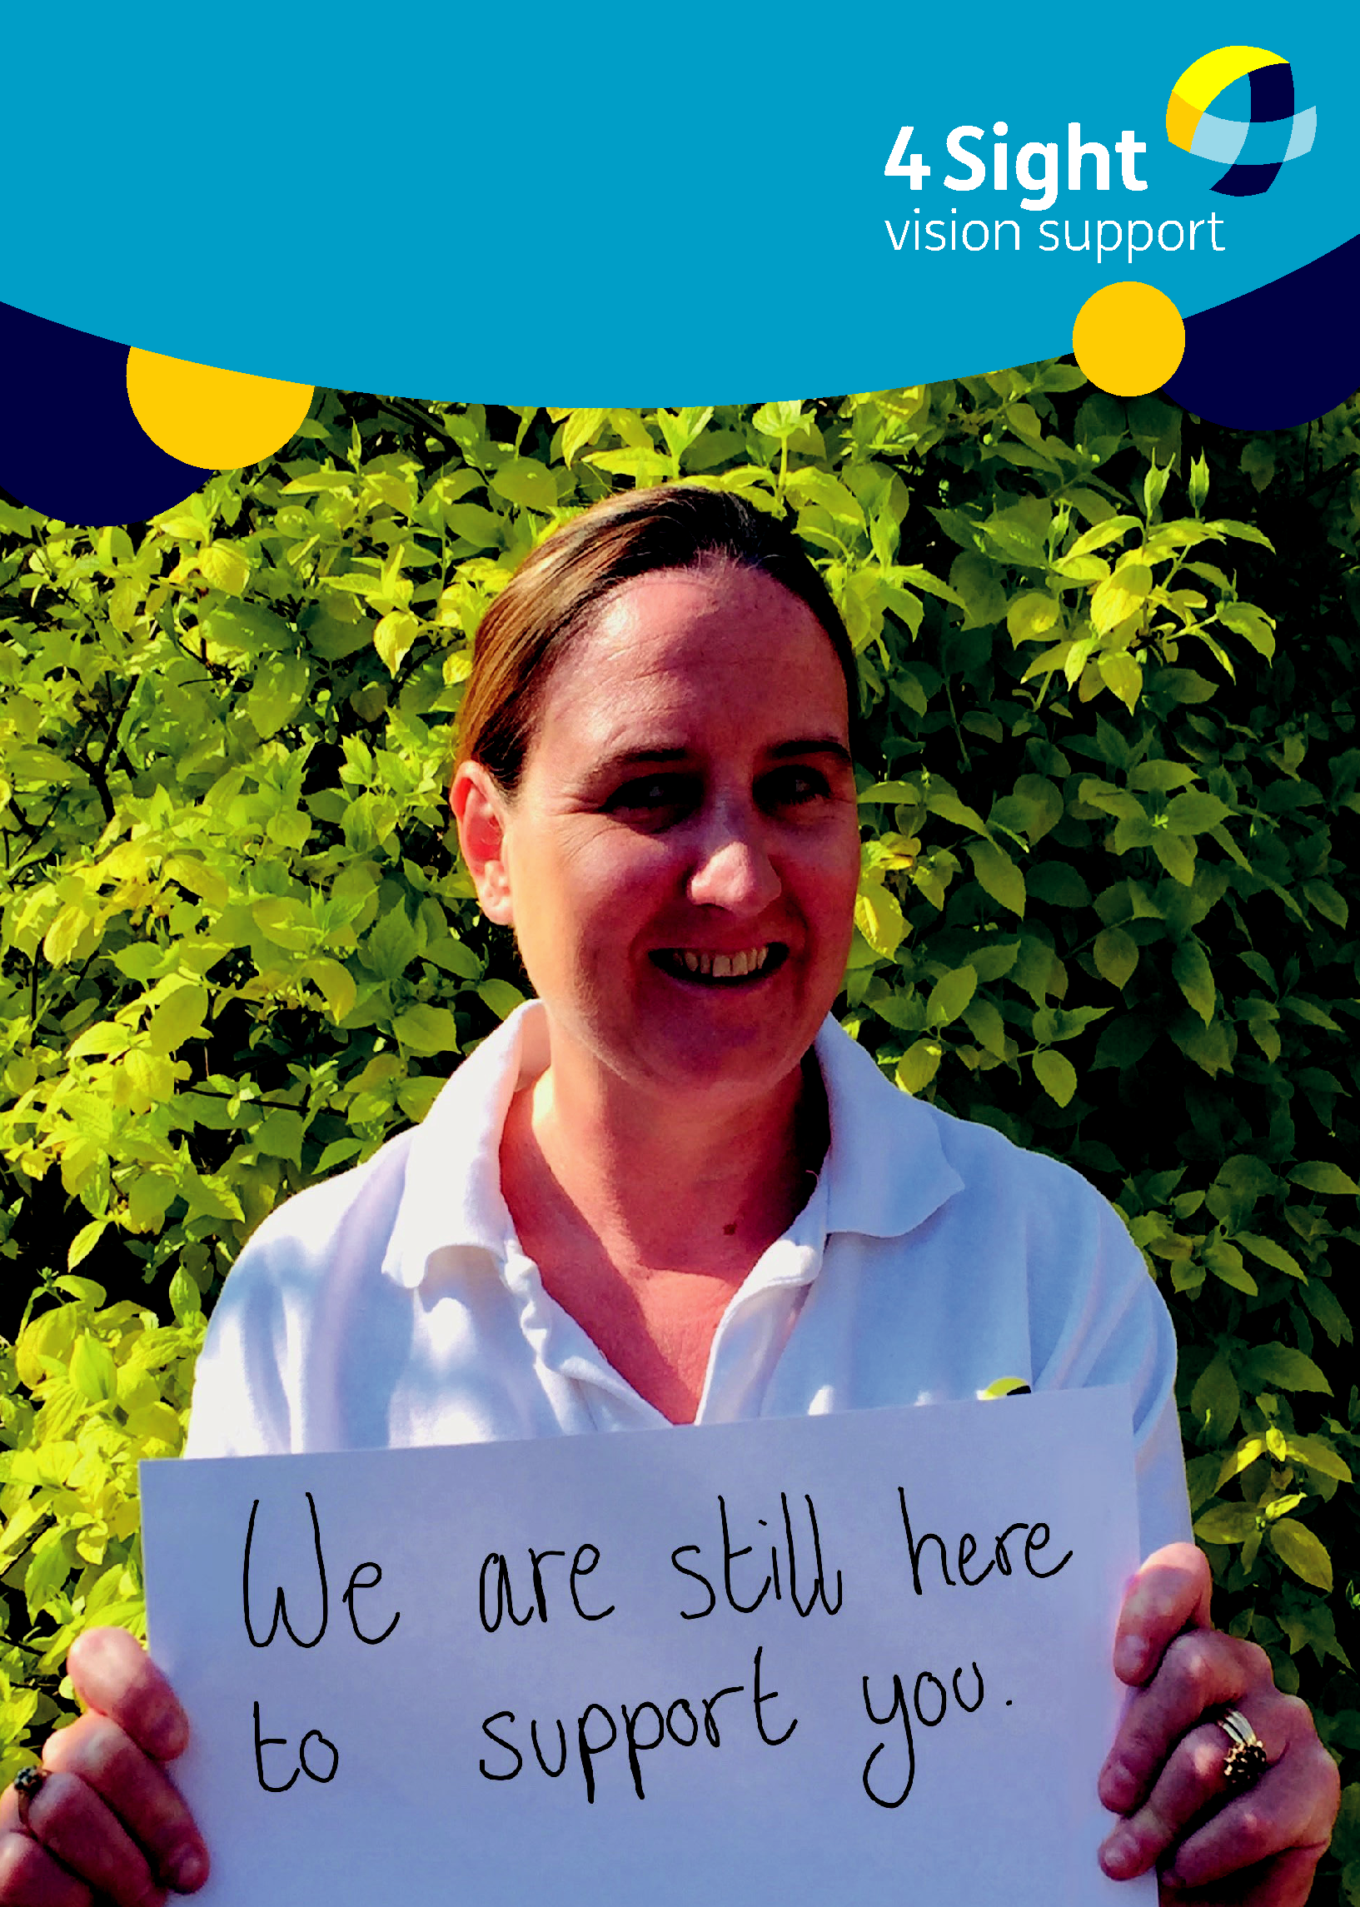
COVID-19
June 2020 Newsletter

In this Issue:

Pg 3: Message from Senior Outreach Worker
Pg 4: Our Support 4 You
Pg 5: Team Contact details
Pg 6: Living in Lockdown
Pg 7: Daily Living Aids
Pg 8: News & Audio books
Pg 9: Be Scam Aware

Pg 10: Our COVID-19 Crisis Appeal

Stay Connected:

Moved house or changed your phone number recently? Please let us know if any of your personal details change so that we can continue supporting you at this time of uncertainty.

Call: 01243 828555
Email: enquiries@4sight.org.uk

Have your say:

If you have any comments on how we can continue to update our services, please let us know:
Call: 01243 828555 or

Email: feedback@4sight.org.uk

We would love to hear from you if you have any ideas for the next newsletter:
Call: 01243 838001 or

Email: marketing@4sight.org.uk

2

Just a little note to say hello...

Message from
Senior Outreach Worker, Kirstie Thomas.

“We are still here to help and provide an over the phone service for your queries on Low Vision aids, eye health, accessible technology and general advice and guidance.

This change to our usual service has been extremely challenging for all and we are making improvements to the service we are offering all the time.

Working from home and not being able to visit our members has been really tough and very frustrating but we are still here for you.

Our aim is to make contact with all our members during this time and check that you are okay.

We have been overwhelmed by the positive and grateful words we have received for the support we have been providing.

Please call with any questions or concerns, or even if you just
want a chat - we can always have
a virtual cuppa! |  | “
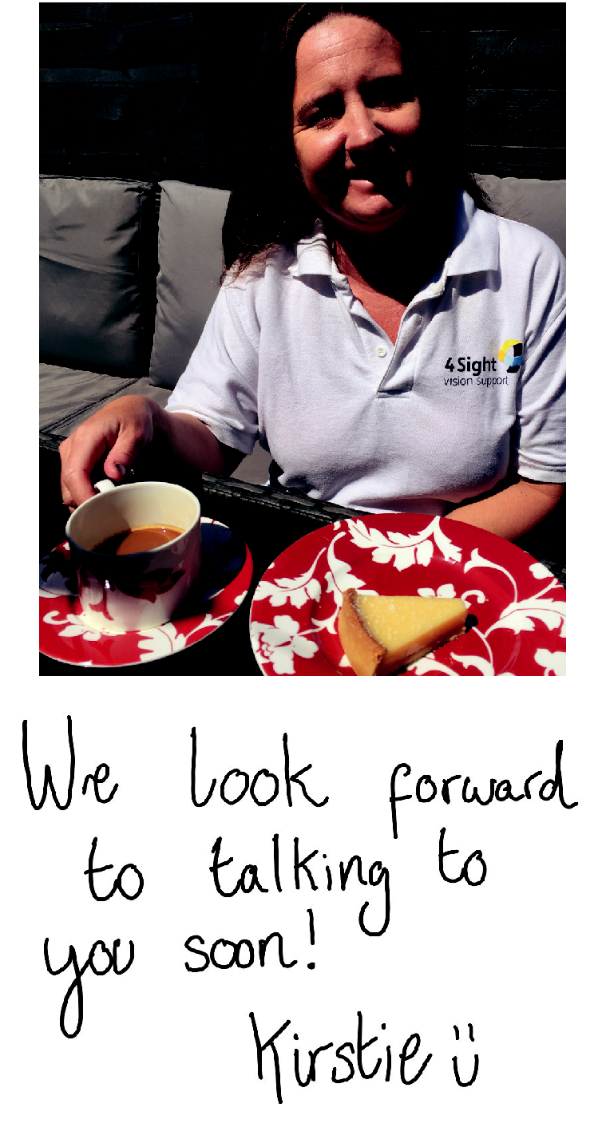

3

Our Support 4 You

Whilst we can't be with you physically, we are still here to support you.

Our Outreach Team and Sight Care Advisors are working from home and can be contacted by phone or email. Contact details can be found on the next page.

Eye Health

If you have a specific query regarding your eye health, please contact one of our Sight Care Advisors - Jan Wise or Annie Taylor.

Tech Advice

If you have specific challenges with electronic devices such as tablets, smart speakers, laptops or TVs, or would like to know more about accessible tech, please contact Tara, Beau or Kirstie.

Daily Living Aids

If you would like some advice or wish to order a daily living aid please contact Beau.

Need a chat

If you are feeling lonely, finding things difficult and don't know where to turn for support, please contact any one of our Outreach Workers.

In addition, the Outreach Workers and a team of Volunteers are proactively calling members to see if anyone needs any support. If we haven't reached you yet, please know that you are on our list!

Lastly, please do continue to check our website and social media for news and updates.

4

Team Contact Details

Kirstie Thomas 07545 501 214 kirstie.thomas@4sight.org.uk
Mon-Fri, 9am – 5pm

Karen Mclachlan
07545 501 215
karen.mclachlan@4sight.org.uk
Mon – Thurs, 9am – 5pm

Bev Tinson
07545 501 218
bev.tinson@4sight.org.uk
Tuesday & Thursday, 9.30am – 3.30pm

Tara Beesley
07545 501 216
tara.beesley@4sight.org.uk
Mon – Fri, 9am – 5pm

Annie Taylor
07858 128 312
antoinette.taylor@nhs.net
Mon – Fri, 9am – 1pm

Jan Wise
07947 310 651
janine.wise@nhs.net
Mon: pm, Tues: am, Wed: all day

Beau Prince
07907 021 202

beau.prince@4sight.org.uk Mon – Fri, 10am – 3.30pm

5

Living in Lockdown Member's Story
Our Outreach Team has had the
privilege of speaking to lots of
our members, hearing how you
have each found ways to live
through lockdown. Here, Pamela |  |  | Even though I can't see to put it
Akehurst, shares her experience: |  |  | on properly and it probably goes
 | I am a normal 80 year old and |  | everywhere, I always put my
 |  |  | lippy on - even if it is just for the
this is my philosophy: we are all |  |  | postman! | “
“
here to help each other. |  |  | Routine
I do get days when I am down and
 |  |  | Some people have told us they
want it to all be over, but I still
 |  |  | have felt anxious during
have a bit of life in me and I am
 |  |  | lockdown. Keeping a routine, like
protecting my children.
 |  |  | Pamela, can help.
It is no good just sitting here all |  |  | The charity Mind has some
day so this is my way of making |  |  | practical advice for staying at
the day more varied, it keeps me |  |  | home and taking care of your
mentally stimulated |  |  | mental health and wellbeing.
I spend my day by setting hourly |  |  | To find out more, visit their
 |  |  | website: www.mind.org.uk and
actions, so I spend an hour doing
 |  |  | click on Coronavirus under the
my exercise usually a walk around
 |  |  | heading 'Information and
my home and garden, listening to
 |  |  | Support'.
my audio books. I also spend time
calling friends and family, I try to |  |  | If you would like to share your
contact different people each day
experiences of living during
lockdown please contact:
jessica.passmore@4sight.org.uk
to see how they are, and talk to
my neighbours through the window

Daily Living Aids

We can still provide you with a range of Daily Living Aids. Please contact Beau Prince on 07907 021 202 to place an order, or for advice on specific pieces of equipment, such as:

Daylight LED Portable Twist Task Lamp

- Easy-Twist' head with automatic ON/OFF operation

when you close the shade PRICE - £55.00
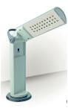

Communiclock
(Radio Controlled Clock)

- Large black button for time and date. With a clear male

voice and adjustable volume PRICE - £36.00
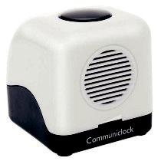

Symbol Cane Lightweight Aluminium Cane PRICE - £14.00

Liquid Level Indicator Lightweight and suitable for a wide variety of cups.

- Beeps and vibration indicates when the cup is nearly full or when the liquid has reached limit

- Suitable for hot or cold drinks

PRICE - £9.00

Sonic 2 USB MP3 Player

- Plays content on USB memory sticks

- Bluetooth Connectivity for pairing with mobile and tablet devices

- Large yellow control buttons

PRICE - £50.00
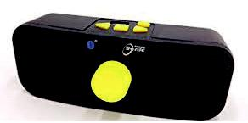

Other items are available, please ask for details. Note it may take a little longer for items to arrive.

7

News & Audio Books

 | Talking Newspapers |  | Audio Books from West Sussex
 | Talking Newspapers can help |  | Libraries
 | you stay updated with local |  | Join the free online library service
 | news and information in your |  | and gain access to thousands of
 | area. You can find out more |  | free eAudiobooks as well as
 | and find your local Talking |  | eBooks, eNewspapers and
 | News by emailing: |  | eMagazines. West Sussex Libraries
 | enquiries@tnf.org.uk or call: |  | have also started to offer delivery
01793 497 555 |  |  | of audiobooks to your home.
 |  |  | For more information call Jackie
 | RNIB Connect Radio
 |  |  | Manners, Principal Librarian
 | RNIB's radio station broadcasts |  | Wellbeing, on 03302 224767.
 | 24hrs a day communicating the
 | needs, interests and aspirations |  | Calibre Audio
 | of visually impaired people |  | Has reopened its CD and memory
 | throughout the UK. |  | stick service for all members and
 | You can listen online, Freeview |  | for any new members, the team
 | channel 730 or simply ask your |  | aim to get their first book in to the
 | Amazon or Google Home |  | post in 48 hours. For more
 | digital device to "...Play RNIB |  | information, contact Calibre Audio
 | Connect Radio" |  | on 01296 432339 or
 |  |  | membershipservices@calibre.org.
 | NEW Facebook Group
 |  |  | uk
 | For those of you on social
 | media, you may be interested
 | to know that we have set up a
 | Facebook group for members
 | to stay connected and share
 | tips. Find the group on our
 | Facebook page @4SightVS .

8

Be scam aware

Advice on avoiding scams during the pandemic.

There has been an increase in scams since the Coronavirus pandemic began, including: •Online shopping - where people buy items like hand sanitiser or face masks which never arrive. •Suspicious / phishing emails and calls offering bogus shopping services or fake Coronavirus tests.

If you have any concerns please contact the West Sussex Community Support team on 0330 222 7980 for advice. Phones are manned 7 days a week, 8am- 8pm.

4Sight Vision Support, along with a consortium of other local charities, has come together to provide the following advice:

•Don’t open the door to anyone calling ‘out of the blue’. •Don’t give money upfront to someone on the doorstep offering to shop for you, unless you know them well and trust them.

•Be aware coronavirus testing is not being offered door to door by statutory bodies.

•Do not click links or open emails from senders you don’t know.

•Buy only from well-known online retailers.

•Do not give out personal information such as bank details, addresses, existing insurance, pension, or investment details.

Reputable organisations, including charities, offering 'doorstep' services will always: •Call in advance.

•Let you know the name of the person to expect.

•Take payment in advance through online/telephone payments.

•Payment will not be taken on the doorstep unless a prior agreement has been made. •Wear ID.

9

Our COVID-19 Crisis Appeal

Over the past few weeks, myself and the team have had the privilege of speaking to over 1,000 of our members, helping in whatever way we can to make life that bit easier during lockdown.

I know many of you have felt isolated before Coronavirus, but since our clubs and other services are not currently running, you are probably feeling this even more keenly. Please be reassured that we will keep working hard to ensure we continue offering the support and advice you might need at this time. Whether this is assistance with magnifiers, advice on eye health, purchase of daily living aids, accessible technology training or just a chat - we are here to support you.

However, as you may be aware, coronavirus has had a huge financial impact on small charities like us, and while demand for our support has increased, income has dropped.

Today, I am asking for your help!

A one-off gift or regular donation could make a significant difference to charities of our size.

For example, just £4 a month could ensure Outreach Workers like myself can be there for one member for a whole year.

To make a donation and secure our services, please complete the form on the next page.

Thank you in advance for your support. Senior Outreach Worker, Kirstie Thomas
