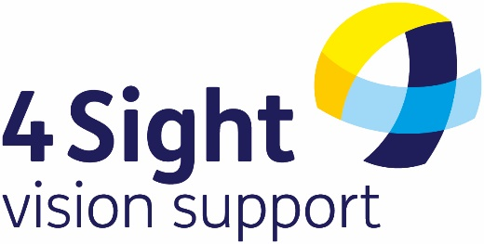

**4SIGHT VISION SUPPORT**

**ANNUAL GENERAL MEETING OF MEMBERS**

**FRIDAY 8TH NOVEMBER 2024**

**Notice of Meeting**

The 2024 Annual General Meeting will be held **at The QEII Room, 1st Floor, The Shoreham Centre, 2 Pond Road Shoreham BN43 5WU**

Friday 8th November 2024 at 11.00am,

Followed by a buffet lunch and refreshments

AGENDA

1. Welcome from the 4Sight Vision Support Chairman.
2. Apologies for Absence (Officers only).
3. Minutes of the Annual General Meeting held on 24th November 2023
4. Report from 4Sight Vision Support Chairman - Dr Norman Boyland.
5. Report from 4Sight Vision Support CEO – Kirstie Thomas.
6. Report from 4Sight Vision Support Hon. Treasurer - Arthur Mayson.
7. Report from our Auditors - Kreston Reeves (to be read out)
8. Annual Trustee Report and Accounts for 2023/2024
9. Election of the existing Trustees.
10. Questions.
11. Closing remarks by the Chairman.

The AGM will be ‘hosted’ by our Chairman, Dr Norman Boyland DL and he will be accompanied in the formal business of the AGM by the Honorary Officers of the Charity and the CEO, all of whom will be active participants in the meeting.

**Proxy Voting:**

If you are unable to attend the meeting, you may appoint the Chairman, Dr Norman Boyland to vote on your behalf, by requesting and returning a **‘Proxy Voting Form’** indicating your voting intentions for agenda items 3, 8 and 9.

**Supporting documentation:**

Copies of the Report of the Trustees and Draft Financial Statements for the year ended 31st March 2024 and the AGM 2023 Minutes will be available on the 4Sight Vision Support website (www.4sight.org.uk) from **1st November 2024**. You can request advance copies of any of these documents, or a copy of the Proxy Voting Form, by calling the 4Sight Vision Support Bradbury Centre on **01243 828 555**, or by emailing **enquiries@4sight.org.uk**.

Kirstie Thomas, Chief Executive and Company Secretary

4Sight Vision Support

4Sight Vision Support Bradbury Centre

36 Victoria Drive

Bognor Regis

West Sussex

PO21 2TE

Tel: **01243 828 555**

Email: **kirstie.thomas@4sight.org.uk**

Website: www.4sight.org.uk

Company Number 3740647 Charity Number 1075447